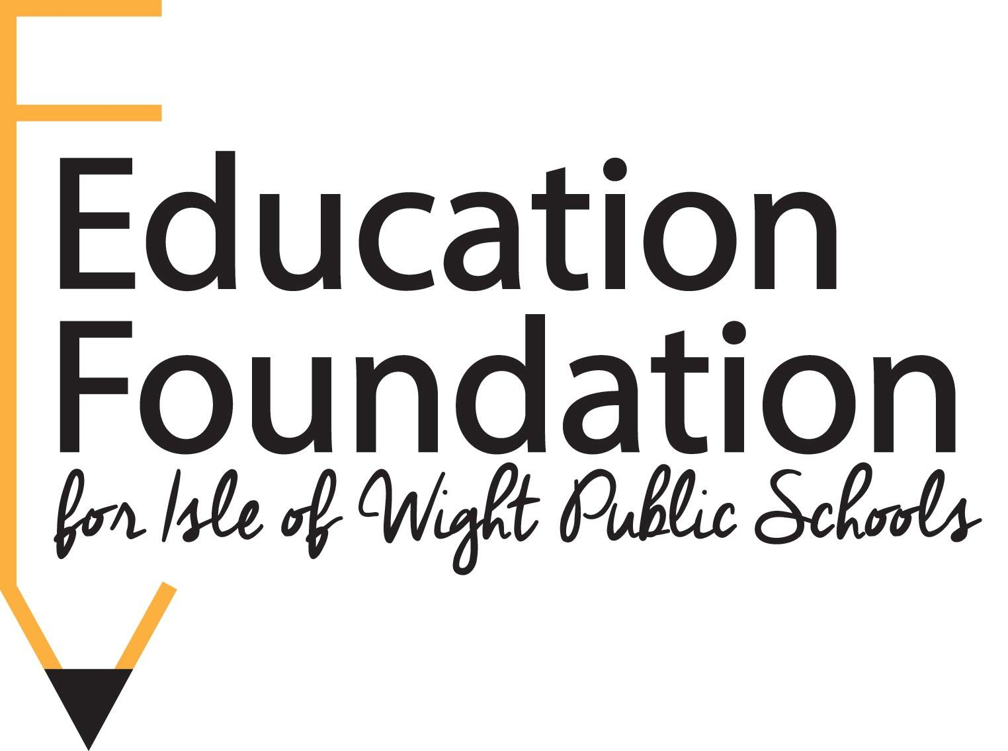
PO Box 113
Smithfield, VA 23431
www.iowfoundation.org
contact@iowfoundation.org

NNovember 8th, 2021

Dear Isle of Wight County Teachers,

Thank you for all that you do for our students in Isle of Wight County. We appreciate your time, energy, and hard work. Many of you go above and beyond what is expected to make sure the students have an outstanding educational experience. As this school year begins, we encourage you to take a few minutes to consider how a grant from the Education Foundation could benefit your students for this upcoming school year.

A grant is a commitment of funds to support an experience, a program, or a project that otherwise might not be funded. Projects may relate to one teacher’s classroom, to the needs of a grade level, to the needs of a particular school, or to the needs of the division. There is no minimum award amount; however, grants can be awarded up to a maximum of $2500.

You can find the application online at www.iowfoundation.org. Applications must be submitted no later than December 15th, 2021. Please pay close attention to the Grant Guidelines as you consider the possibilities.

The funds that we dedicate to our Educational Grants program come directly from our many generous sponsors and supporters of our annual fundraising event. Through the success of our events in past years, the Education Foundation was able to award more than $25,000 in grants..

We hope that you are having a successful school year and look forward to reading your grant submissions this school year.

Sincerely,

The Grant Committee
Education Foundation for Isle of Wight Public Schools

Board of Directors
Andrea May, President Patrick Bloodgood, Vice President
Amy Bowman, Treasurer Kakisha Williams, Secretary
Margaret Bachman Lynn Briggs David Elliott
Bessie Cameron Cat Breckenridge Jessica DiStefano

